Name: Akhil K J

Title: Network Administration and Troubleshooting Using Windows Command Line Utilities.

Date of Assignment provided: 26/09/2022

Aim: To study more various Windows command-line utilities to perform troubleshooting in the network.

Tools Required: Command Prompt(Administrator),

Result: Have understood some of the windows command-line utilites and known more about network connections.

1. Command Prompt to be run as administrator.

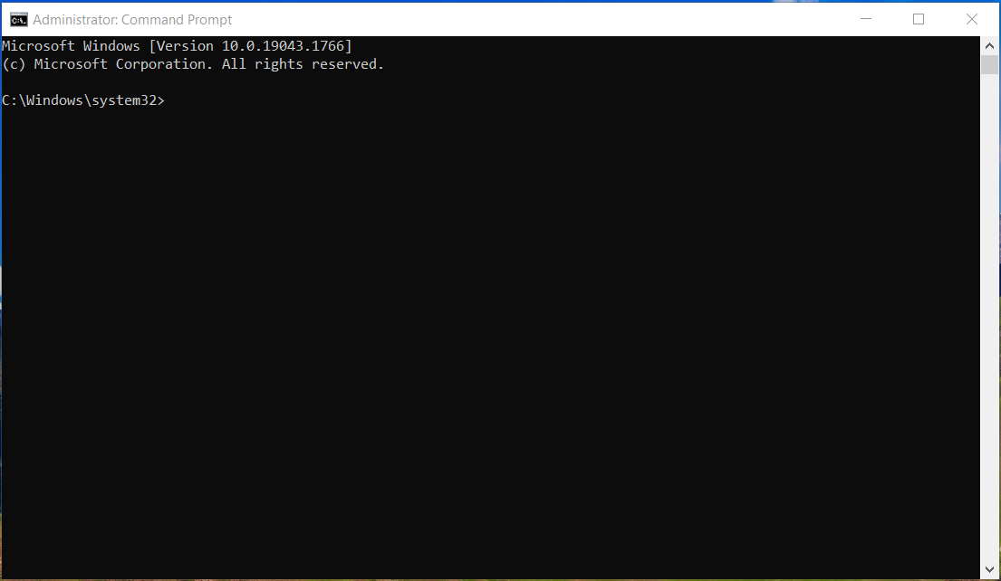

1. **Ipconfig** command is used to display all the TCP/IP connection values.

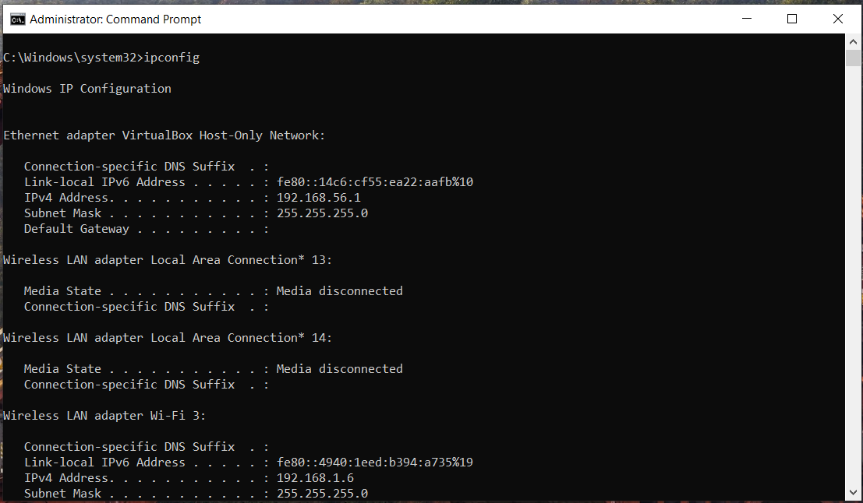

1. **Ipconfig/all** displays all configuration information of each adapter bound to TCP/IP including DHCPv6, DNS server etc.

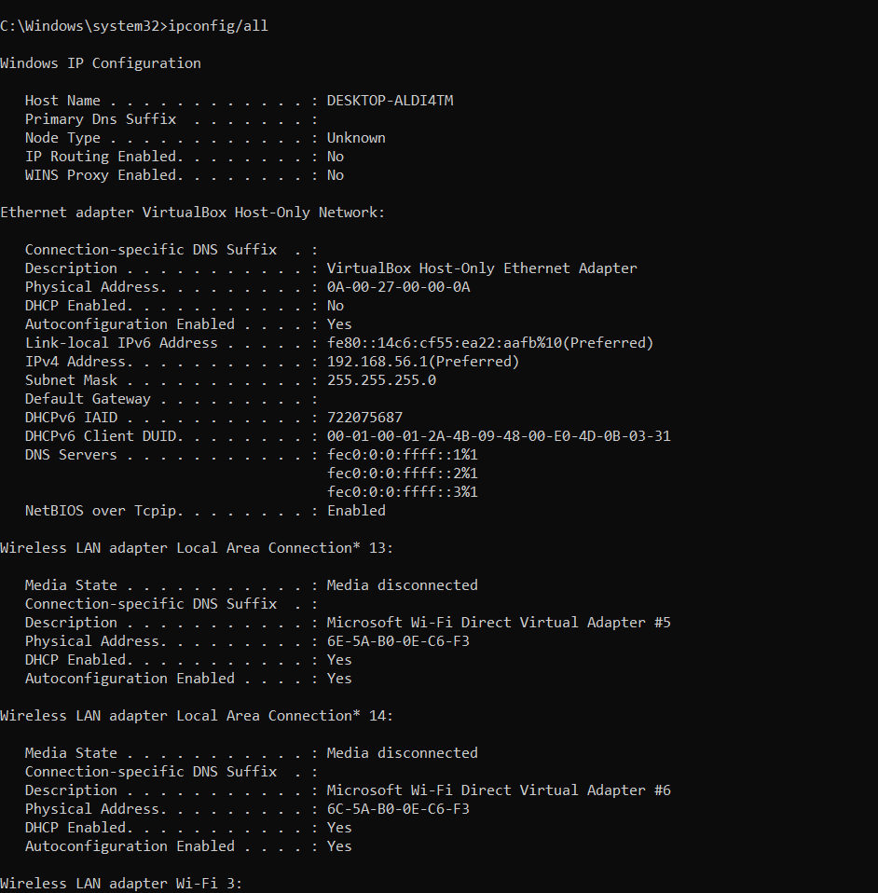

1. **Ping <IP>** is used to test and verify a IP of the computer network.

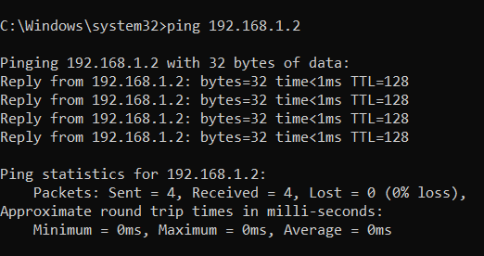

1. **Tracert IP** is used to trace the route to

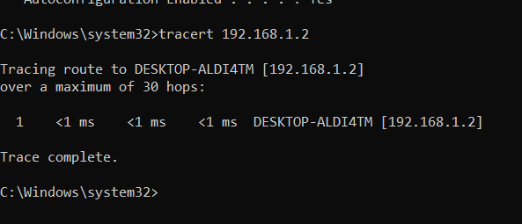

1. **Nslookup** command can be used to get the configuration information of a DNS network. **Nslookup type –a** is used to specify a networks ip address.

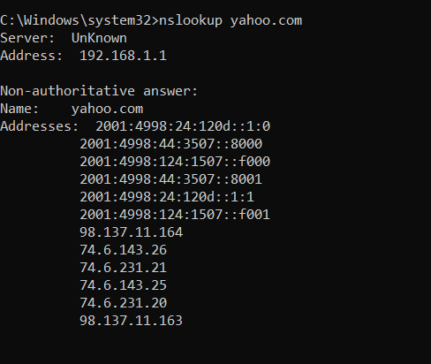

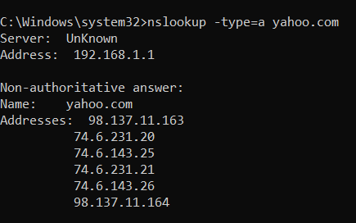

1. **Nslookup type soa** command gives the information of primary mail server, mail address, the expiry of the number etc.

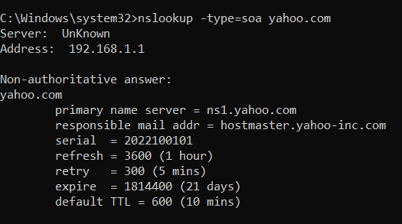

1. **Netstat** command is used to know the current update of the network.

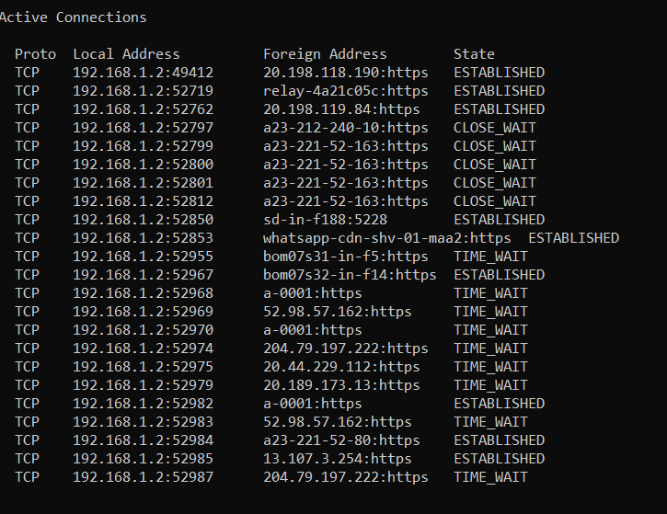

1. **Arp –a** command is used to map IP addresss with their repective MAC address.

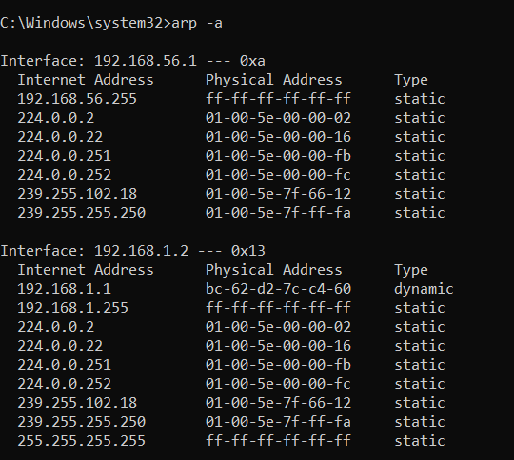

1. **Gpresult** displays the resulting set of policy settings on the computer.

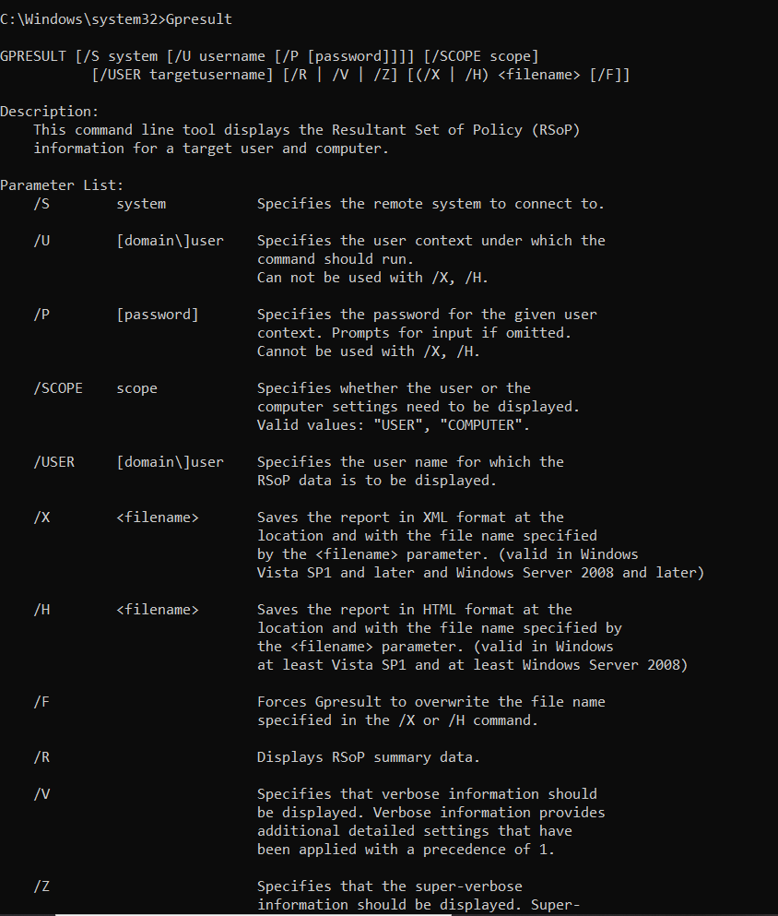

1. **Ipconfig/flushdns** flushes the DNS Resolver Cache.

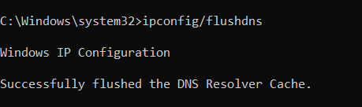

1. **Nbstat –a** is used to display protocol settings and shows different commands and their uses.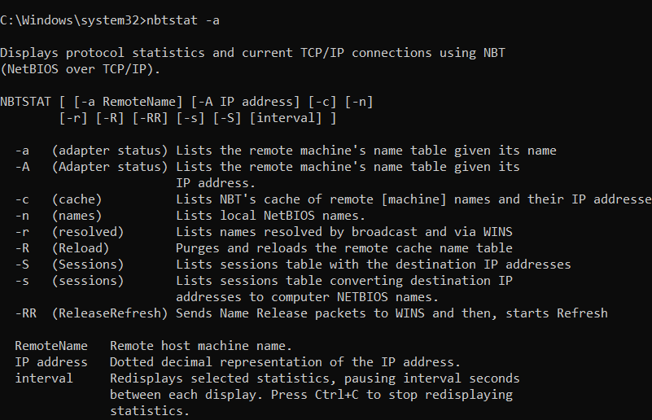
2. **Nbstat ip** is used to

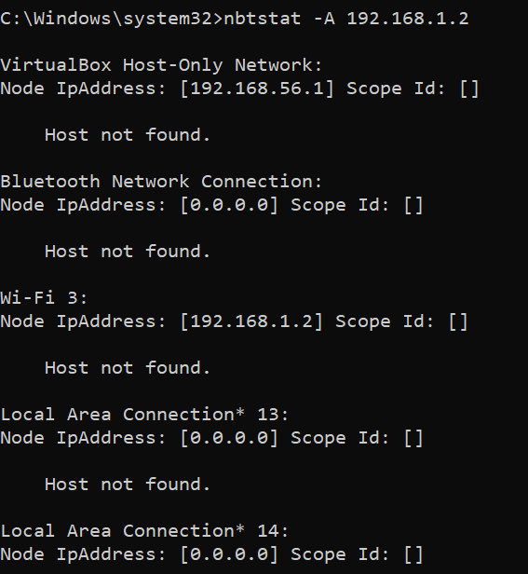

1. **Nbstat- R** is used to purge and preload the Remote Cache Name table. **Nbstat –r** is used for detecting errors in WINS.

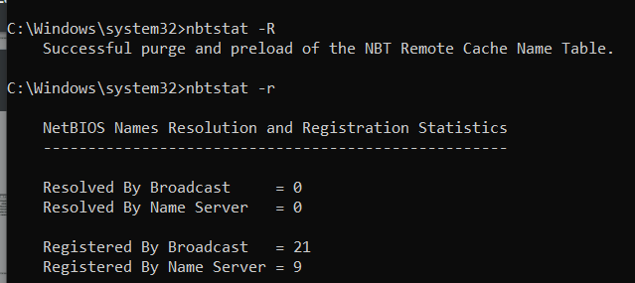

1. **Nbstat –n** is used to list the BIOS names.

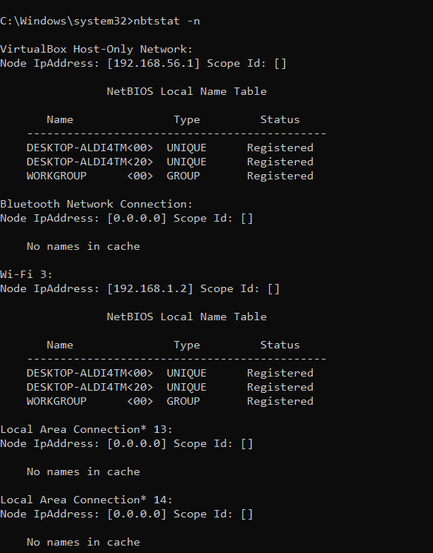

1. **Netstat –ab** is used to show network status.

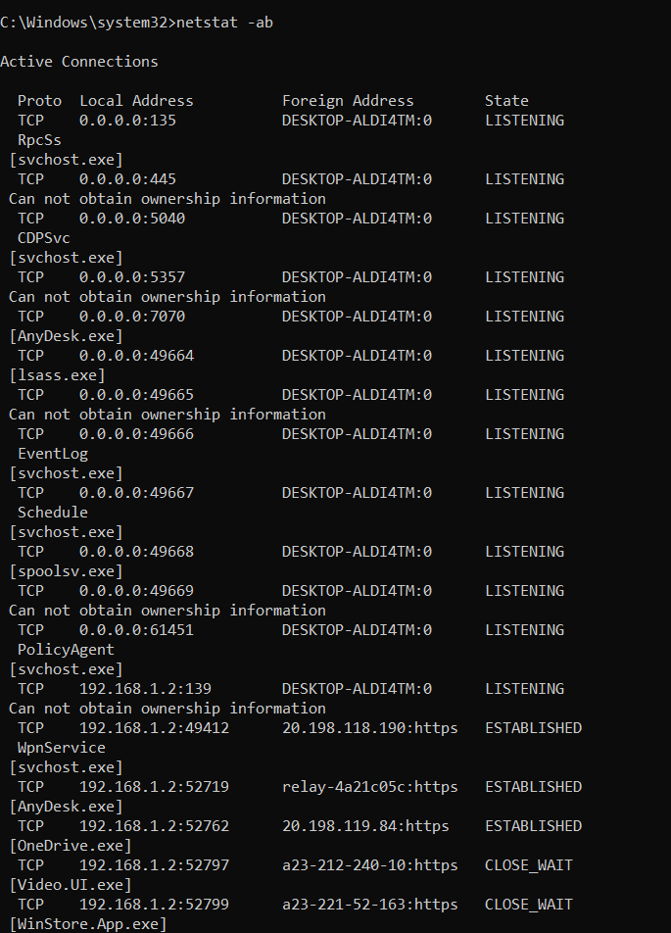

1. **Netstat an** is used to display protocol statistics and current TCP/IP network connections.

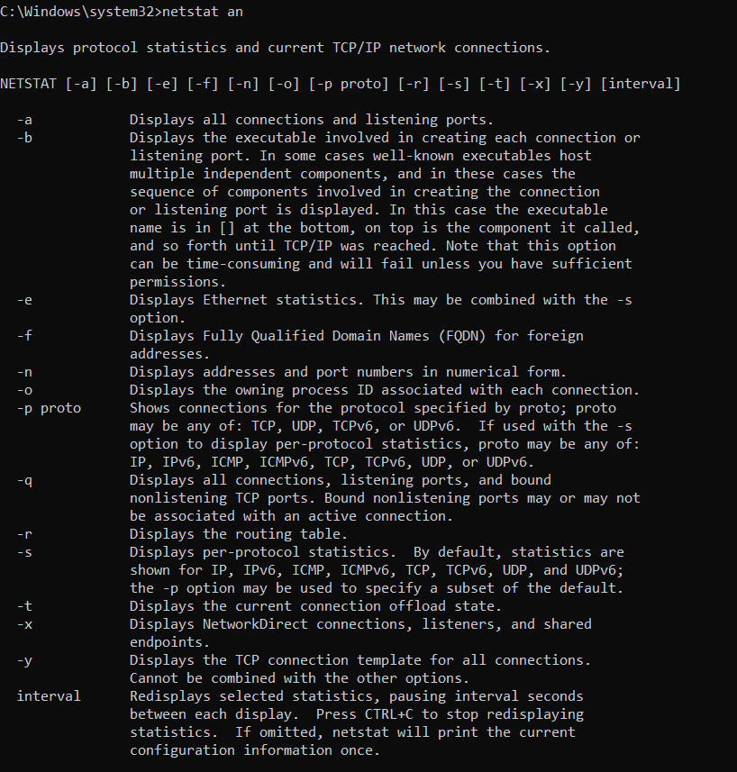

1. **Pathping** is used to measure the quality of network connections.

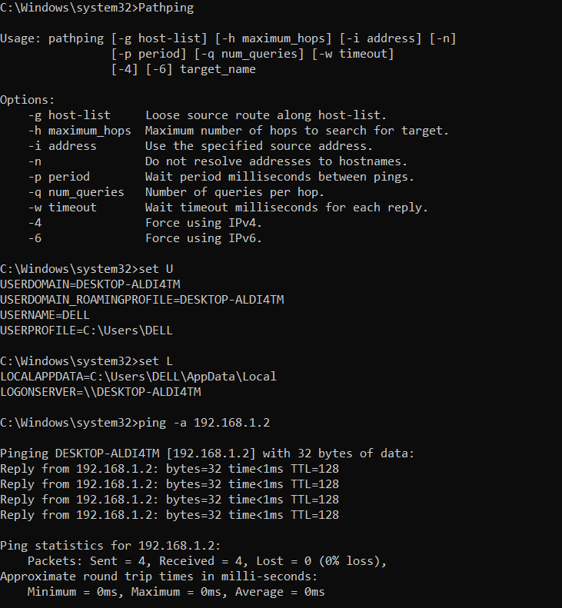

**Set U** is used to shows the name of the user logged in.

**Set L** is used to show the log on server

Ping –a <IP> is used to resolve IP to hostname.

1. **Netstat –an|find”LISTENING**” is used to show the open ports with opening status.

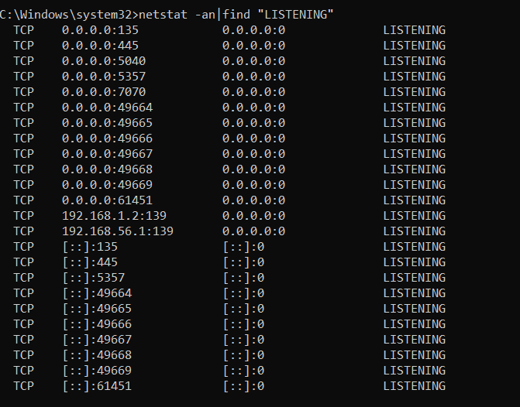

1. **Ipconfig /displaydns** displays the contents of DNS Server.

**Ipconfig /registerdns** register for the DNS client resolve.

**Ipconfig /showclassid** Adapter shows the operationhas been failed as it has no adapter.

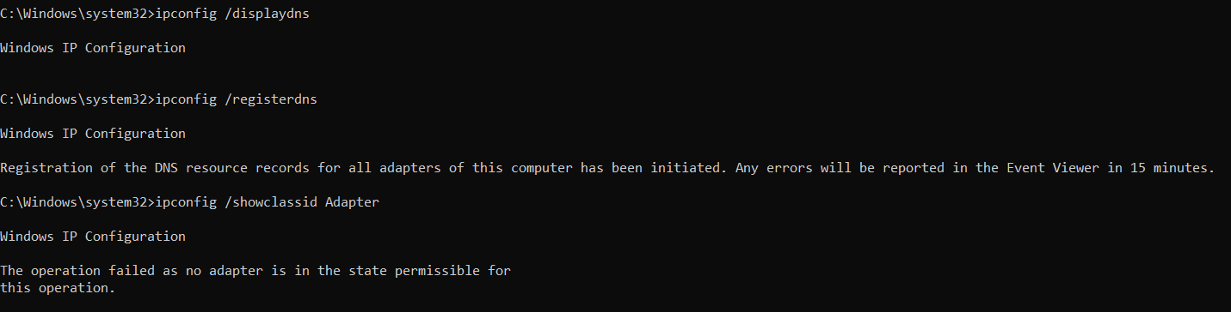

1. **Netstat –s** displays the IPv4, IPv6, IOPv4, IOPv6 and TCP statistics.

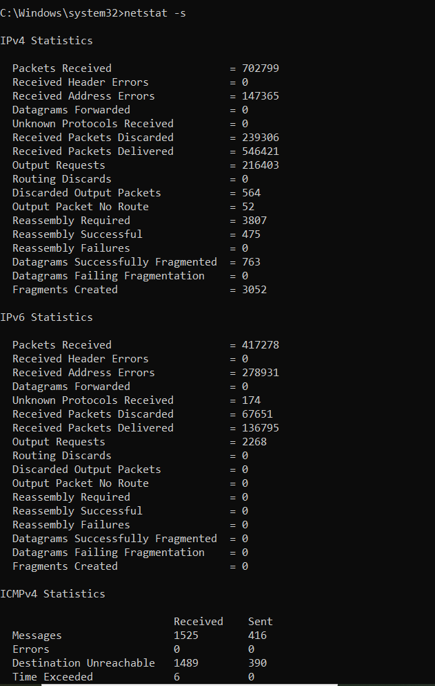

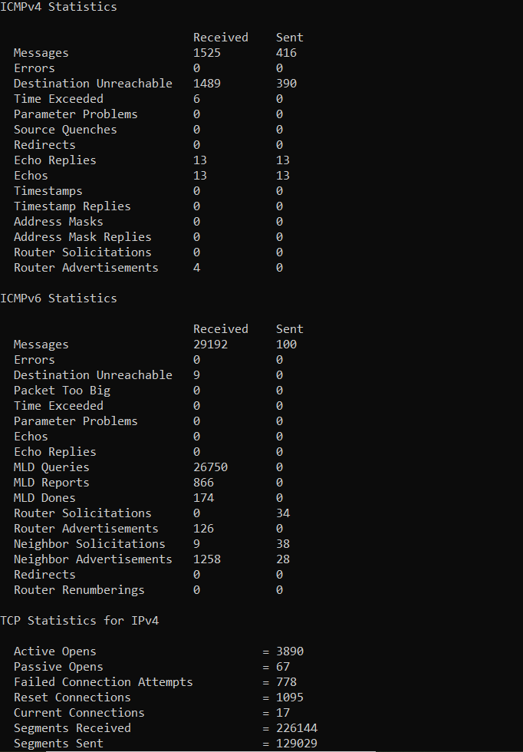

1. **Ping <IP> -f** is used for fragmentation with 32 bytes of data.

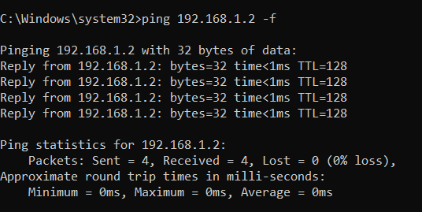

1. **Netstat –o** is used to display TCP connections and Process ID(PID)

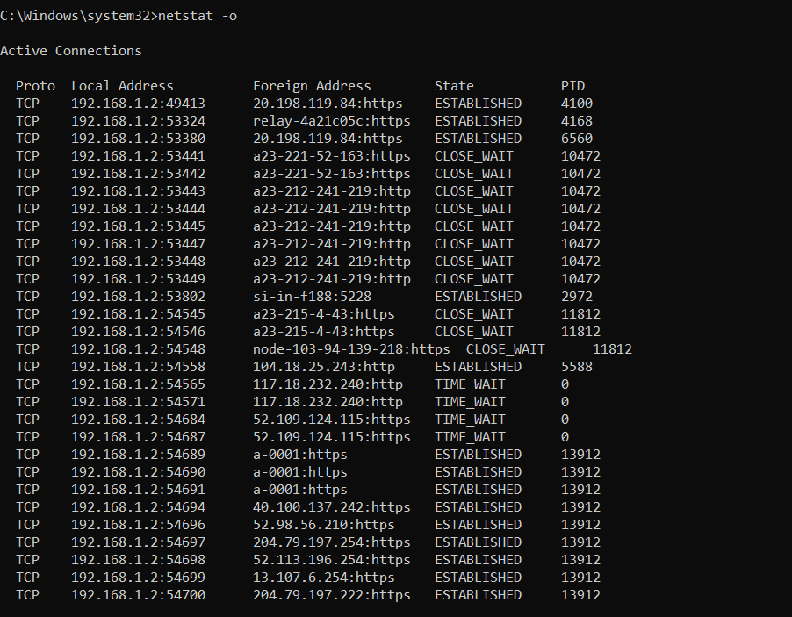

1. **Netstat –r** displays the contents of IP routing table.

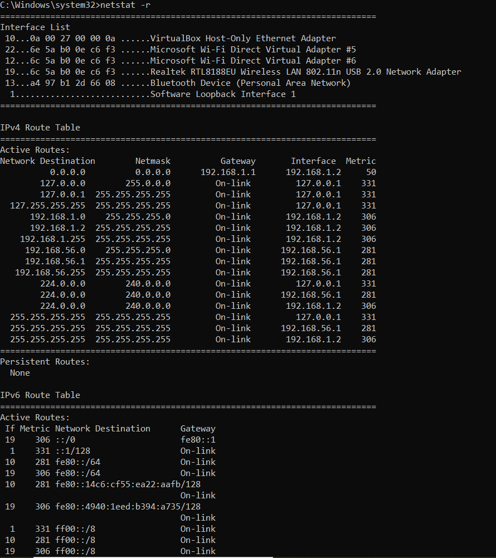

1. **Ipconfig /renew** is used to renew the IPv4 address for the specified adapter.

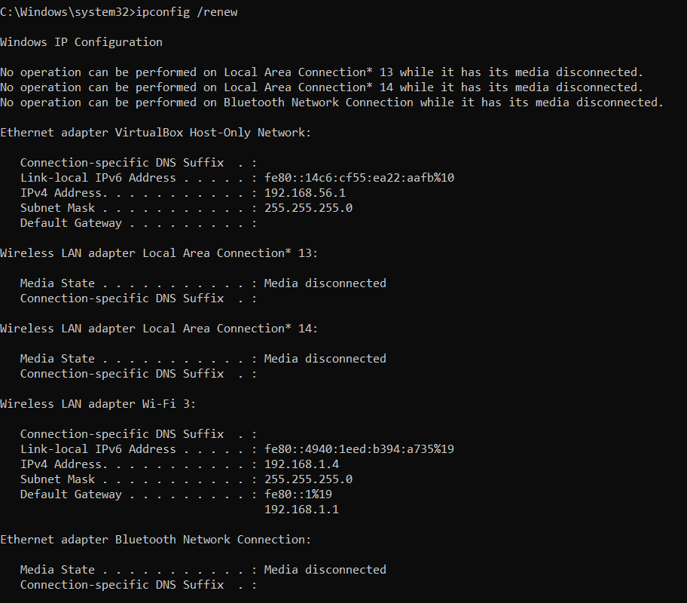

1. **Ipconfig /showclassid** is used to display all the dhcp class IDs allowed for adapter.

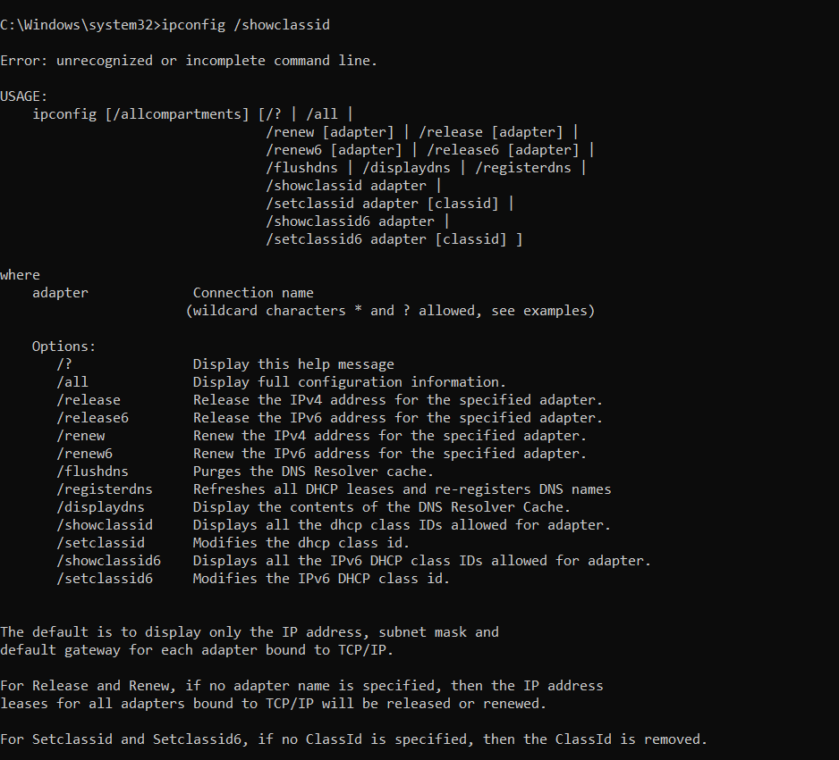

1. **Net user** is used to show user for the computer.

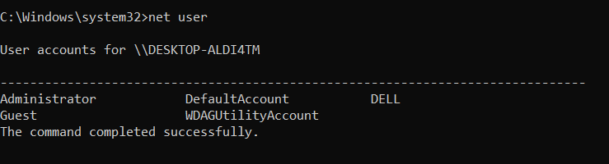

1. **Net user/domain** specifies computer available in specific domain.

